CURRICULUM VITAE

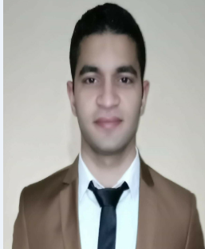
Personal information:
First name: Ahmed Samir abd elbaki
Last name: barakat
Address: kafr – elzayat / gharbiya
Date of birth: 19/09/1994.
Driving license: NO
Military force: performed
Marital status: single

Contact information:
01270078389
01023752448
Gmail : ahmedsamiremara020@gmail.com
EDUCATION:
FACULTY OF SCIENE Tanta UNIVERSITY
Bachelor in computer science
From 2013- to 2017.
GPA: very good

Skills
Computer Skills:
- Excellent in using computer software and hardware.
- Operating system programs (Microsoft office).
- Maintaining computer (software, hardware).
- Excellent in using Microsoft office ( excel – word – PowerPoint – outlook )
- Excellent in maintaining computer software and hardware

- Personal skills
- Perfect in communication and presentation skills.
- Work under stress and in team.
- Flexible and perfect listener
- Active and sociable

Languages:
Arabic: native language
English: very good
French: good

Courses:
no | Course name | institute | duration | date
1 | Icdl course | Delta center | 3 months | 2017
2 | English course | online | 7 months | 2018
3 | Cisco certified network associated | online | 7 months | 2019

Service experience:
- Worked in food company as data entry and writing import and export permits for customers
- Worked as an order taker (receiver of customer complains) in Concord el-Salam hotel
- Worked as a technical support (it) in fantasia resort marsa alam
- Worked as a customer service in etisalat
- Worked as a customer service in Vodafone
- Worked as an Student Affairs Director in 6 October academy
- Worked as a lecturer in computer science department

